Election Day - "The Decisive Hour" Jesus said
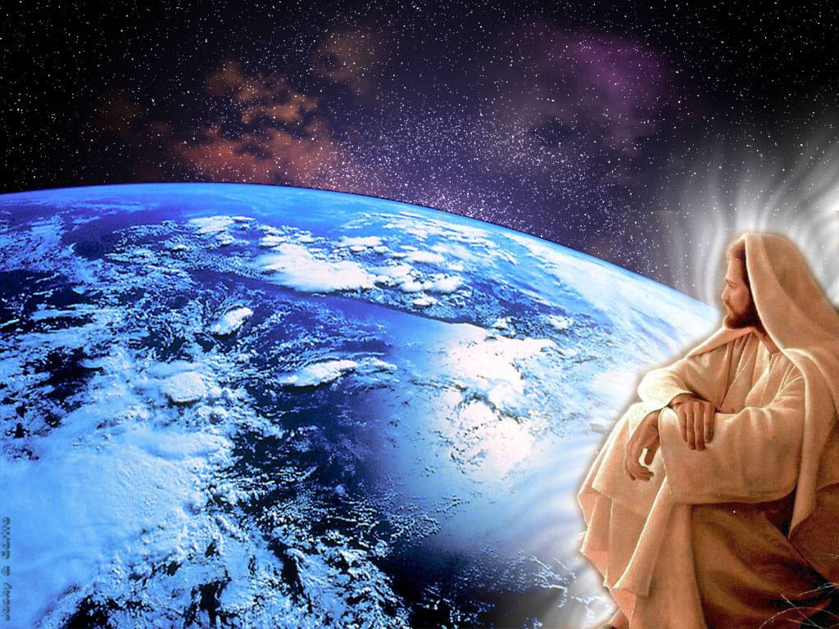
November 8, 2016

May the Lord bless America on this critical day.

Well, Heartdwellers, today is a very important day. And tonight is a critical night. And the Lord began His message immediately.

He began, "Tonight IS a critical night. There is a stillness in Heaven. Those who have shouldered this burden and prayed - I commend you. You are truly carrying My Cross for the world. Those of you who have longed for the day when righteousness would be established in your country, it will never be so until I come. But steps could be taken to at least move in that direction. The first being to put a total end to abortion.

"Just as the man of sin began his reign in America by allowing babies to be cut into pieces in their mother’s wombs, the first act of righteousness would totally ban the practice and begin the steps to ban abortion in America forever. What heavy judgments would be removed from this country were that to take place. What peace could be established at her borders. Can I bless and protect a nation that slaughters innocent children? Surely I cannot. But an end to this practice would lift the severe judgment on this land.

"There is still a hidden monster to be dealt with, it continues to expand under the soil like the infamous Blob monsters of the 60’s."

Just as an aside here, that is the image He gave me. I remember as a teenager - I wasn't a Christian - and I used to watch movies about the Blob. That's what I saw when He was speaking this to me.

He continued, "One only has to dig a couple of feet to see it. It is that nefarious force that will eventually arise from the ground and swallow everything in its grasp. These are the hidden agendas, the black ops, the place where tremendous amounts of tax dollars go to destabilize governments and establish cooperative leaders through terror, butchery and intrigue. This is also the force behind ISIS and the planned Muslim takeover of America, resulting in the slaughter and beheading of Christians and Jews.

"This is another force that must be curtailed in this country. It brings curse after curse upon the citizens of the land because they are spreading injustice through their money.

"Clare, there is more than enough resource in this country to bring continents like Africa totally out of poverty and establish the land in sustainable living. But because the resources are being used for selfish ambition and genocide, the poor of the world continue to suffer.

"I will put an end to this when I come. No longer will one man have an over abundance and another, nothing but dirt to fill his stomach with. No longer will babies be born dead. No longer will women and children be conscripted as slaves. No more will rape be common. No longer will children go without opportunity to do something meaningful with their lives. I will supply everyone equally, there will no longer be injustice.

"But until that day you must make do with what you have and the obstacles you encounter in living a just life and extending My love and care to those around you. Until the time comes for Me to purify the Earth and bring you home.

"So what am I saying here? Do your very best to share and provide for those around you even as My Father in Heaven rains upon the just and unjust alike. Share with those around you and it will go well with you when I establish My reign on the Earth.

"Do not support injustice, do not turn a deaf ear or a blind eye to those in need. Reach out and cover them with your own provision, then you will have done unto your neighbor as I have done unto you.

"Do not call evil, good and good, evil. Do not be ignorant of the scheming of the devils to deprive widows of their support and the elderly of what they have invested for their latter years. Yes it is true, the help of man is vain, but I do uphold those who are honest and crooked behavior I abhor.

"But above all, labor to bring the lost into My Kingdom, because when they come to know Me and My ways, they will no longer cheat, steal and be unjust. The heart must be converted, not just the laws. Once the heart belongs to Me, then the laws will follow. The highest calling you can have on this Earth is to bring Me to souls and teach them how to follow Me.

"Yes, following is so very important. I will lead those who will be led. I will prove My power through the lowly, meek and humble. These are those who follow the instructions I put in their hearts. They are not busy for themselves, but busy for those who have no one to comfort them, those who walk in utter darkness, those who truly do not know Me.

"But I tell you a truth: unless you know Me, truly know ME and not just about Me, you will fail in your attempts to bring souls to Me in the ways of love, not legalisms. It is one thing to know Me through the Scriptures and quite another to listen to My heartbeat and carry out daily the desires of My heart for you - even from moment to moment.

"It is one thing to know all about holiness; quite another to live it because you value the smile on My face more than all the laurels and accomplishments of the world - even the religious world.

"Your knowledge of Me must be intimate, your love for Me authentic. Not born of fear, but born of head-over-heels love. If you do not have this love ask Me for it and I will not deny you.

"To have this love, you must be willing to follow Me anywhere. You must spend substantial time in silent adoration and prayer. Worship in spirit and truth from the heart in such a way that you are intimately bonded to Me in purity, and your heart beats in unison with Mine.

"To have this you must put away the rushing around the world offers you daily, and still your soul until you find yourself sitting on Daddy’s lap, hugging His neck and resting upon His shoulder. Yes! This is the intimacy I long for, this is the intimacy you must have to bring others into My Kingdom.

"You can no longer just love Me. You must be in love with Me. When you are in love with Me nothing is too much to do for Me. You have no limits because love has overtaken you and nothing and no one but Me matters to you any longer.

"This kind of love comes only with intimacy, with gazing into My eyes, resting on My shoulder and longing to be in My presence. When you are in love, you will do anything for Me. I am calling you all to take another look inside.

"Do you love Me because I am powerful? Wise? Majestic and the King of all Kings? Because I healed you? Because I made you wealthy? Because you have been successful? Because I am God and it is your duty?

"Or do you love Me because you have known Me and gazed into My eyes and will never be the same again? Do you love Me to distraction, or are you continually distracted by yourself?

"To be My disciple, to spread My truth, you must have more than head knowledge. Please, at this decisive hour in history, look within, are you head-over-heels in love with Me as I am with you, Beloved?"

